# Jonathan Reyes

CSE 446

HW2

# RestService Project

The Project RestService is the answer to question 5. It is a WCF Service converted to be restful. It’s major parts are the Iservice1.cs and Service1.svc

Its target framework is 4.6.1

# MVCWebApp Project

The Project MVCWebApp is the answer to question 6.1. The MVC project targets the .NET Core 2.1 framework.

# Testing Screenshots

(on startup)

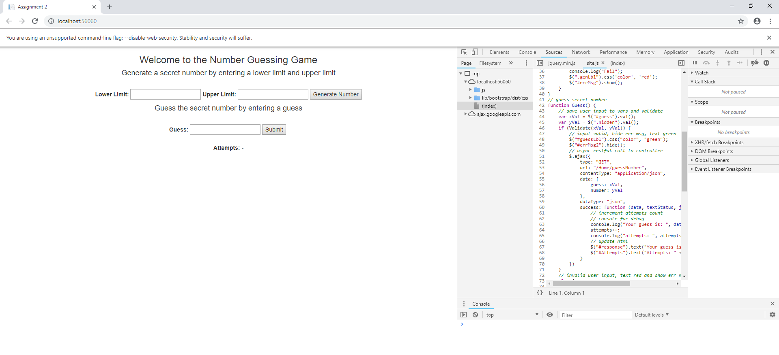

(no valid params passed)

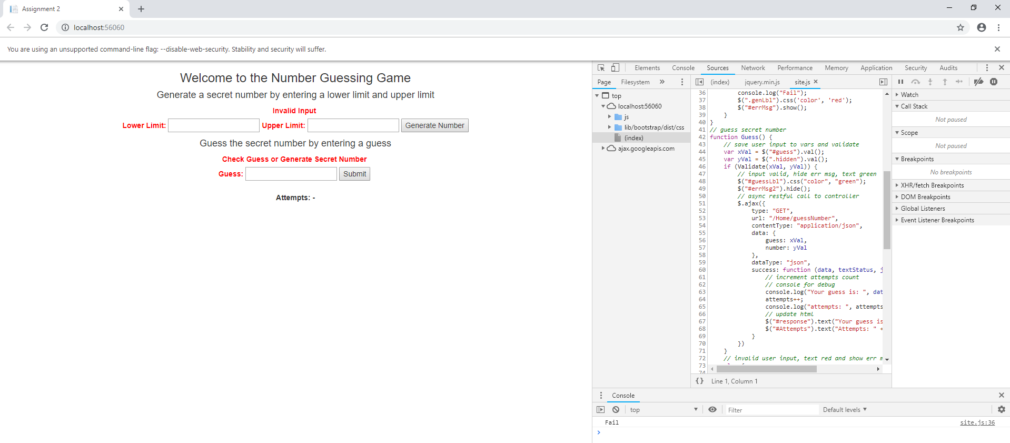

(secret number generated from restful call. The secret number is printed to developer console for debug purposes)

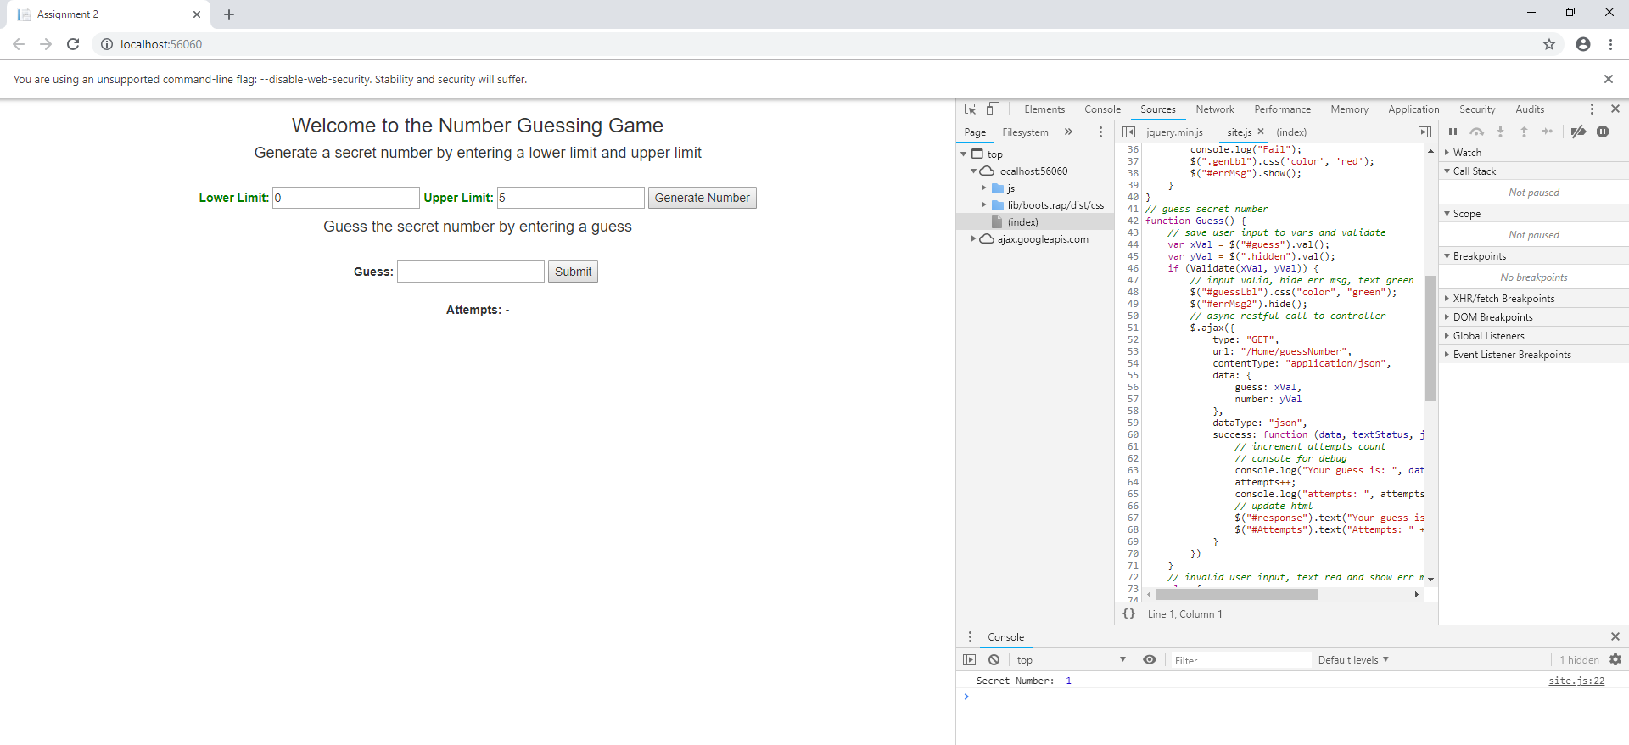

(guessed number too small then too big and finally guessed correct number. Each guess is printed to developer console)

